**Introduction to Tableau**

**Getting Started**

**Tableau Workspace**

The Tableau workspace is a collection of worksheets, menu bar, toolbar, marks card, shelves, and a lot of other elements about which we will learn in sections to come. Sheets can be worksheets, dashboards, or stories. The image below highlights the major components of the workspace. However, more familiarity will be achieved once we work with actual data.

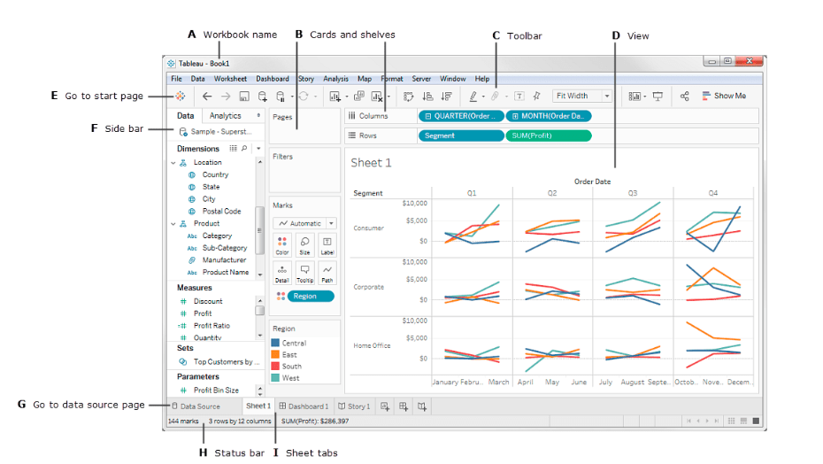

**Connecting to a Data Source**

To begin working with Tableau, we need to connect Tableau to the data source. Tableau is compatible with a lot of data sources. The data sources supported by Tableau appear on the left side of the opening screen. Some commonly used data sources are excel, text file, relational database or even on a server. One can also connect to a cloud database source such as Google Analytics, Amazon Redshift, etc.

The launch screen of Tableau Desktop shows the available data sources that one can connect too. It is also dependent on the version of Tableau since the paid version offers more possibilities. On the left side of the screen, there is a Connect pane which highlights the available sources. File types are listed first, followed by common server types, or the servers that have been recently connected. You can open previously created workbooks under Open tab. Tableau Desktop also provides some sample workbooks under Sample Workbooks.

**Connecting to the Sample-Superstore data set**

We will be working with a sample data set names **Superstore dataset**, that comes pre-loaded with Tableau. The data is that of a superstore. It contains information about products, sales, profits, etc. ***Our aim as Data Analysts is to analyze the data and find critical areas of improvement within this fictitious company.***

**Steps**

1. Import the Data into tableau workspace from the computer.
2. Under the Sheets Tab, three sheets will become visible – Orders, People, and Returns. However, we will focus only on Orders data. Double click on Orders Sheet, and it opens just like a spreadsheet.
3. We observe the first three rows of data looks a bit different and is not in the desired format. Here we make use of **Data Interpreter**, also present under Sheets Tab. By clicking on it, we get a nicely formatted sheet.

**Creating a View**

We will start by generating a simple chart. In this section, we will get to know our data and will begin to ask questions about the data to gain insights. There are some important terms that we will encounter in this section.

Dimension

Measures

Aggregation

[**Dimensions**](https://onlinehelp.tableau.com/current/guides/get-started-tutorial/en-us/get-started-tutorial-drag.html) are qualitative data, such as a name or date. By default, Tableau automatically classifies data that contains qualitative or categorical information as a dimension, for example, any field with text or date values. These fields generally appear as column headers for rows of data, such as Customer Name or Order Date, and define the level of granularity that shows in the view.

[**Measures**](https://onlinehelp.tableau.com/current/guides/get-started-tutorial/en-us/get-started-tutorial-drag.html) are quantitative numerical data. By default, Tableau treats any field containing this kind of data as a measure, for example, sales transactions or profit. Data that is classified as a measure can be aggregated based on a given dimension, for example, total sales (Measure) by region (Dimension).

[**Aggregation**](https://onlinehelp.tableau.com/current/guides/get-started-tutorial/en-us/get-started-tutorial-drag.html) is the row-level data rolled up to a higher category, such as the sum of sales or total profit.

Tableau automatically sorts the fields in Measures and Dimensions. However, for any anomaly, one can change it manually too.

**Steps**

1. Go to the worksheet. Click on the tab Sheet 1 at the bottom left of the tableau workspace.

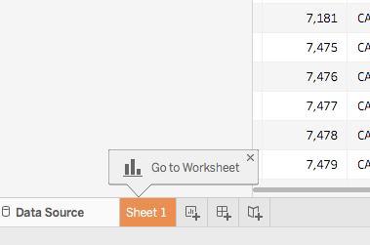

1. Once, you are in the worksheet, from Dimensions under the Data pane, drag the Order Date to the Column shelf. *On dragging the Order Date to the columns shelf, a column for each year of Orders is created in the dataset. An 'Abc' indicator is visible under each column which implies that text or numerical or text data can be dragged here. On the other hand, if we pulled Sales here, a crosstab would be created which would show the total Sales for each year.*
2. Similarly, from the Measures tab, drag the Sales field onto the Rows shelf. *Tableau populates a chart with sales aggregated as a sum. Total aggregated sales for each year by order date is displayed. Tableau always populates a line chart for a view that includes time-field which in this example is Order Date*



**What does the line chart above convey? Well, it shows that the sales look quite promising and appear to be increasing with time. This is a valuable insight, but it hardly says much about the products which are contributing to increased Sales. Let us delve further to get more insights.**

**Refining the View**

Let’s delve deeper and try to find out more insights regarding which products drive more sales. Let's start by adding the product categories to look at sales totals in a different way.

**Steps**

1. Category is present under the Dimensions pane. Drag it to the columns shelf and place it next to YEAR(Order Date). The Category should be placed to the right of Year. In doing so, the view immediately changes to a bar chart type from a line. The chart shows the overall Sales for every Product by year.

To view information about each data point (that is, mark) in the view, hover over one of the bars to reveal a tooltip. The tooltip displays total sales for that category. Here is the tooltip for the Office Supplies category for 2016:

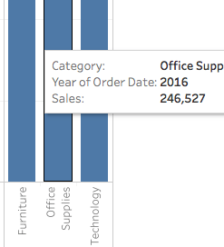

1. To add labels to the view, click Show Mark Labels on the toolbar.

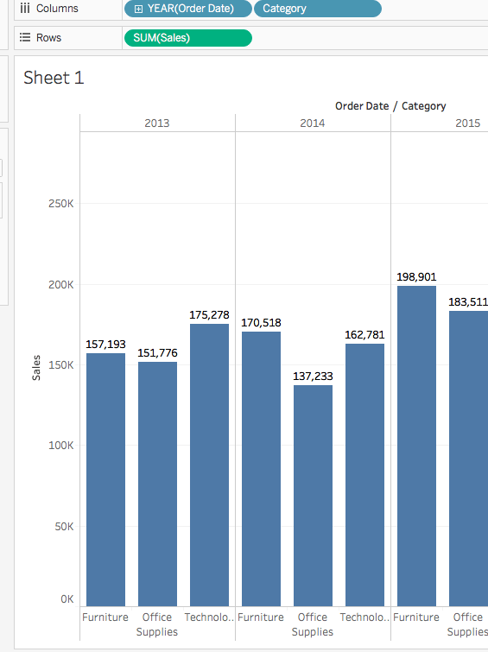

1. The bar chart can be displayed horizontally instead of vertically too. Click Swap on the toolbar for the same.



1. The view now nicely shows sales by category, i.e., furniture, office supplies, and technology. We can also infer that furniture sales are growing faster than sales of office supplies except for 2017. Hence it will be wise to focus sales efforts on furniture instead of office supplies. But furniture is a vast category and consists of many different items. How can we identify which furniture item is contributing towards maximum sales?

To help us answer that question, we decide to look at products by Sub-category to see which items are the big sellers. Let's say for the **Furniture** category; we want to look at details about only bookcases, chairs, furnishings, and tables. We will Double-click or drag the Sub-Category dimension to the Columns shelf.

The sub-category is another discrete field. It further dissects the Category and displays a bar for every sub-category broken down by category and year. However, it is a humongous amount of data to make sense of visually. In the next section, we will learn about filters, color, and other ways to make the view more comprehensible.

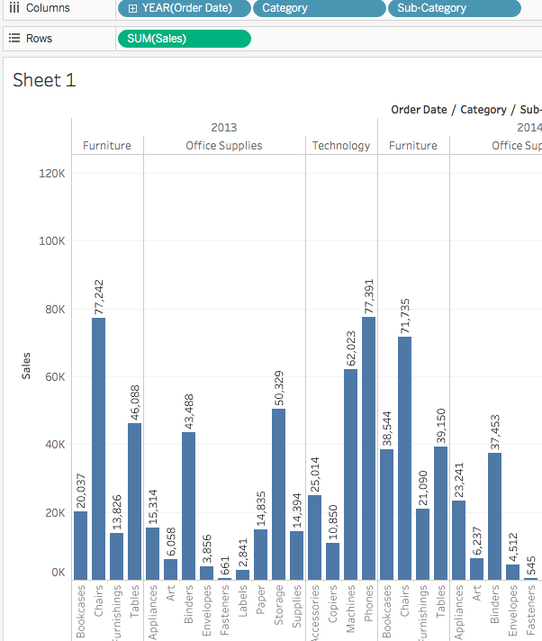

**Emphasizing the Results**

In this section, we will try to focus on specific results. Filters and colors are ways to add more focus to the details that interest us.

**Adding filters to the view**

Filters can be used to include or exclude values in the view. Here we try to add two simple filters to the worksheet to make it easier to look at product sales by sub-category for a specific year.

**Steps**

1. In the Data pane, under Dimensions, right-click Order Date and select Show Filter. Repeat for Sub->category field also.

Filters are the type of cards and can be moved around on the worksheet by simple drag and drop.



**Adding colors to the view**

Colors can be helpful in the visual identification of a pattern.

**Steps**

1. In the Data pane, under Measures, drag Profit to Color on the Marks card.

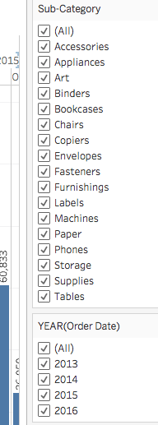

**It can be seen that Bookcases, Tables and even machines contribute to negative profit, i.e., loss. A powerful insight.**

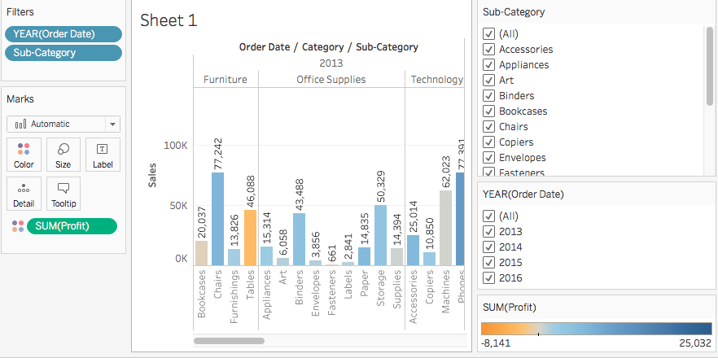

**Key Findings**

Let's take a closer look at the filters to find out more about the unprofitable products.

**Steps**

1. In the view, in the Sub-Category filter card, uncheck all boxes except Bookcases, Tables, and Machines. This brings to light an interesting fact. While in some years, Bookcases and Machines were actually profitable. However, in 2016, Machines became unprofitable.
2. Select All in the Sub-Category filter card to show all the subcategories again.
3. From the Dimensions, drag Region to the Rows shelf and place it to the left of the Sum(Sales) tab. We notice that machines in the South are reporting a higher negative profit overall than in your other regions.
4. Let us now give a name to the sheet. At the bottom-left of the workspace, double-click Sheet 1 and type Sales by Product and Region.
5. To preserve the view, Tableau allows us to duplicate our worksheet so that we can continue in another sheet from where we left off.
6. In your workbook, right-click the Sales by Product and Region sheet and select Duplicate and rename the duplicated sheet to Sales-South.
7. In the new worksheet, from Dimensions, drag Region to the Filters shelf to add it as a filter in the view.
8. In the Filter Region dialogue box, clear all check boxes except South and then click OK. Now we can focus on sales and profit in the South. We find that machine sales had a negative profit in 2014 and again in 2016. We will investigate this in the next section.
9. Lastly, do not forget to save the results by selecting File > Save As. Let us name our workbook as Regional Sales and Profits.



**Map View**

Map views are beneficial when we are looking at geographic data (the Region field). In the current example, Tableau automatically recognizes that the Country, State, City, and Postal Code fields contain geographical information.

**Steps**

1. Create a new worksheet.
2. Add State and Country under Data pane to Detail on the Marks card. We obtain the map view.
3. Drag Region to the Filters shelf, and then filter down to South only. The map view now zooms in to the South region only, and a mark represents each state.
4. Drag the Sales measure to the Color tab on the Marks card. We obtain a filled map with the colors showing the range of sales in each state.
5. We can change the color scheme by clicking Color on the Marks card and selecting Edit Colors. We can experiment with the available palettes.
6. We observe that **Florida** is performing the best regarding Sales. If we Hover over Florida, it shows a total of 89,474 USD in sales, as compared to South Carolina, for example, which has only 8,482 USD in sales. Let us gauge the performance by Profit now since Profit is a better indicator than Sales alone.
7. Drag Profit to Color on the Marks card. We now see that Tennessee, North Carolina, and Florida have negative profit, even though it appeared they were doing good in Sales. Rename the sheet as Profit Map



**Getting into the Details**

Maps empower us to visualize the data broadly. In the last step, we discovered that we discovered that Tennessee, North Carolina, and Florida have a negative profit. In this section let’s draw a Bar chart to explore the reason for the negative profit.

**Steps**

1. Duplicate the Profit Map worksheet and name it Negative Profit Bar Chart.
2. Click Show Me on the **Negative Profit Bar Chart** worksheet. Show Me presents the number of ways in which a graph can be plotted between items mentioned in the worksheet. From Show Me select the horizontal bar option and the view updates to horizontal from vertical bars instantly.
3. We can select more than one bar at a time by simply clicking and dragging the cursor over them. We want to focus only on the three states, i.e., Tennessee, North Carolina, and Florida. Hence, we will only select the bars pertaining to them.

**Creating Hierarchies**

Hierarchies come in handy when we want to group similar fields so that we can quickly drill down between levels in the viz.

1. In the Data pane, drag a field and drop it directly on top of another field or right-click the field and select
2. Drag any additional fields into the hierarchy. Fields can also be re-ordered in the hierarchy by simply dragging them to a new position. In the current viz. we will create the following hierarchies:
   1. Location
      1. Country
      2. State
      3. City
      4. Postal Code
   2. Order
      1. Order ID
      2. Order Date
      3. Ship Date
      4. Ship Mode
   3. Product
      1. Product Name
      2. Sub-category
      3. Category
      4. Product ID



1. On the Rows Shelf, click the plus-shaped icon on the State Field to drill-down to the City level.
2. That's a lot of data. We can use N-Filter to filter and reveal the weakest performers. For that, drag City from the Data pane to the Filters shelf. Click By field and then Click the Top drop-down and select Bottom to reveal the weakest performers. Type 5 in the text box to show the bottom 5 performers in the data set.

We now see that Jacksonville and Miami, Florida; Burlington, North Carolina; and Knoxville and Memphis, Tennessee are the poorest performing cities by profit. There is one other mark in the view—Jacksonville, North Carolina—that doesn't belong here since it has profitable sales. This means there is an issue in the filter we applied. We will take the help of Tableau Order of Operations.

1. On the Filters shelf, right-click the Inclusions (Country, State) set and select Add to Context. We find that now Concord(North Carolina) appears in view while Miami(Florida) have disappeared. This makes sense now.
2. But Jacksonville (North Carolina) is still present which is incorrect. On the Rows shelf, click the plus-shaped icon on City tab to drill down to the Postal Code level. Right-click the postal code for Jacksonville, NC, 28540, and then select Exclude to exclude Jacksonville manually.
3. Drag Postal Code off the Rows shelf. This is the final view.



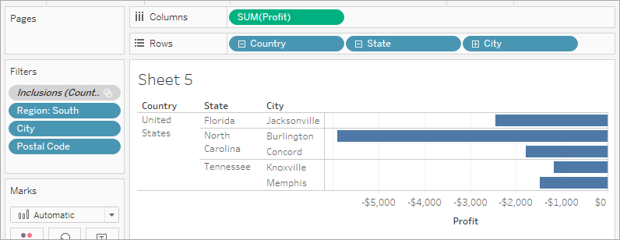

**Key Findings**

Let’s now focus only on the loss-making entities, i.e., the Products and let us identify the locations where such products are sold.

**Steps**

1. Drag Sub-Category to the Rows to further drill down.
2. Similarly, drag the Profit to Color on the Marks card. This enables us to spot products with negative profit quickly.
3. Right-click the Order Date and select Show Filter. It seems that Machines, tables, and binders are performing poorly. So, what should we do? One solution would be to stop the sale of these products in Jacksonville, Concord, Burlington, Knoxville, and Memphis? Let's verify if our decision is right.
4. Let’s head back to previously created Profit Map sheet tab.
5. Now, click on the Sub-Category field to select the Show Filter option.
6. Drag Profit from under Measures onto the Label Marks card.
7. Again, click on the Order Date and select Show Filter. From the filter let’s clear off the items which we think are contributing to negative profit. So, uncheck the boxes in front of Binders, Machines, and Tables respectively. Now we are only left with the profit-making entities. This shows that the entities like Binders, machines, and tables were actually causing losses in some areas, and we were right in our findings.

**Creating a Dashboard**

A dashboard is a collection of several views, enabling one to compare a variety of data simultaneously.

**Steps**

1. Click the New dashboard button.
2. Drag Sales in the South to the empty dashboard
3. Drag Profit Map to the dashboard and drop it on top of the Sales in the South view. Both views can be seen at once. To be able to present data in a manner so that others can understand it we can arrange the dashboard to our liking.
4. On the Sales South worksheet in the dashboard view, click under the Region and clear off the Show Header. Repeat the same process for all the other headers. This helps to emphasize only what is needed and hides away the not so important information.
5. On the Profit Map, Hide the Title as well and perform the same steps for the Sales South map.
6. We can see that the Sub-Category filter card and Year of Order Date have been repeated on the right-side. Let us get rid of the extra by simply crossing them out. Finally, click on the Year of Order Date. A drop-down arrow appears and select the option of Single Value (Slider). Now let the magic unfold. Experiment by choosing different years on the slider and the Sales also vary accordingly.
7. Drag the SUM(Profit) filter to the bottom of the dashboard below Sales in South for a better view.



**Adding Interactiveness**

To make the dashboard more interactive like viewing which sub-categories are profitable in which states, a few changes need to be done.

**Steps**

1. Let's start with the Profit Map. On clicking the map, a Use as filter icon appears in the upper right. Click on it. If we select any map, Sales corresponding to that state will be highlighted in the Sales-South map.
2. For the Year of Order Date, click on the drop-down option and go to Apply to Worksheets > Selected Worksheets. A dialog box opens. Select the All option followed by OK. What does this option do? It applies filters to all the worksheets having the same data source.
3. Explore and experiment. In the visualization below, we can filter the Sales South map to view products that are being sold in North Carolina only. We can then easily explore the profits yearly.
4. Rename the Dashboard to Regional Sales and Profit.



Thus, selling machines in the North Carolina did not bring any profits to the company.

**Building a Story**

A dashboard is a cool feature, but tableau also offers us to showcase our results in presentation mode in the form of stories about which we will discuss in this section.

**Steps**

1. Click the New story button.
2. From the Story pane on the left, drag the Sales in the South worksheet (created earlier) onto the view.
3. Edit the text in the gray box above the worksheet. This is the caption. Name it as Sales and profit by year.
4. Stories are quite specific. Here we will tell a story about selling machines in North Carolina. In the Story pane, click on Duplicate to duplicate the first caption, or you may even create a new one.
5. In the Sub-Category, filter select only Machines. This helps to gauge sales and profit of machines by year.
6. Rename the caption to Machine sales and profit by year.



**Making a Conclusion**

It is clear that machines in North Carolina are leading to loss of profit. However, this cannot be demonstrated by looking at Profit and Sales on the whole. For this, we need regional Profit.

**Steps**

1. In the Story pane, select Blank. Drag the already created dashboard Regional Sales and Profit onto the canvas.
2. Caption it as Low performing items in the South.
3. Select Duplicate to create another story point with the Regional Profit dashboard. Select North Carolina on the bar chart since we are interested in showing more about it.
4. Select All the years.
5. Add a caption for clarity, like, Profit in NC : 2013-2016.
6. Select any year like 2014. Add a caption, for example, Profit in NC : 2014 and then click on the Duplicate tab. Repeat the same step for all the remaining years.
7. Click on the presentation mode and let the story unfold.



Now we have an idea about, what products were introduced to the North Carolina market when, and how they performed. Not only have we identified a way to address negative profit but have also successfully managed to back it with data. This is the advantage of Story in Tableau.